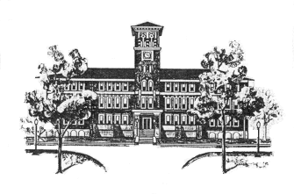
THADDEUS STEVENS COLLEGE OF TECHNOLOGY

Physical Exam

Student’s Name: Sex: Age: Date of Birth: ____/____/____
Physical Examination (to be completed by physician).

Height: __________ Weight: __________ Pulse: __________ BP_ __/_ __

FINDINGS NORMAL ABNORMAL FINDINGS

MEDICAL
- Appearance
- Eyes/Ears/Nose/Throat
- Lymph Nodes
- Heart
- Pulses
- Lungs
- Abdomen
- Skin
MUSCULOSKELETAL
- Neck
- Back
- Shoulder/Arm
- Elbow/Forearm
- Wrist/Hand
- Hip/Thigh
- Knee
- Leg/Ankle
- Foot

ASSESSMENT OF EXAMINING PHYSICIAN
_____ Cleared without limitation.
_____ Cleared after completing evaluation/rehabilitation for:
_____ Not cleared for:

Recommendations:
Name of Physician (please print): Date:
Address:
Phone # Fax #:
Signature of Physician: Date:

